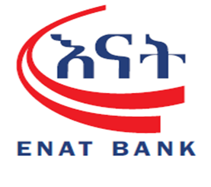

Factsheet for IT operation and service delivery Audit
The Audit team assessed IT operation and service delivery on Digital Banking Operation. Accordingly, the
Following gaps or findings were identified.
s/n | Condition and Criteria | Possible Cause, Effect and Recommendations | Auditee’s Response | Target Date / dependency
 | CONDITION  There is no defined and documented role matrix for users of digital technology platforms.  CRITERIA  Enat Bank SC Information security procedure 2025 page 26 at 4.7.2 Separation of duties | EFFECT  - There will be the risk of unauthorized access, role overlap, and unclear accountability.  RECOMMENDATION  Role matrix should be define and documented for digital banking platforms, clearly assigning responsibilities and segregation of duties. | The existing "Maker" and "Checker" roles within our digital platforms fulfill the requirement for a defined role matrix. These roles clearly segregate duties and responsibilities for all users. However, in collaboration with Digital Technology Department the document can be prepared.
 | CONDITION  During the audit engagement, we observed gaps related to digital banking support including :  - No call log management system, call-based case management, or resolution procedure exists for digital banking operations via the contact center.  - There is no centralized contact center to manage digital banking support requests.  - Complaint handling logbook and call log records, quarter based log analysis and report for hotline 9845 (digital payment support) are not maintained.  CRITERIA  NBE Directive ONPS/02/2020 (Articles 18 & 19).  NBE Directive ONPS/09/2023 (Articles 12.2. i ) | EFFECT  - Risk of unresolved issues, poor customer experience, and lack of accountability in digital banking operations.  RECOMMENDATION  Establish a centralized contact center for digital banking with call log management and case resolution procedures. | We have recognized the importance of call center we have developed call center establishment proposal from digital operation support and digital lending, side line with we have developed F&Q.  We have established logbook for compliant handling purpose.  /////////////////////  To address this gap, a formal proposal for the establishment of a modern contact center has already been drafted and submitted. This proposed solution is specifically designed to implement a call management system and structured resolution procedures, which will ensure proper logging, tracking, and analysis of all digital banking support requests.  Call center Annex 5 | The implementation process will be held soon after CEO approval
 | CONDITION  There is no centralized dispute management system in place to track, manage, and resolve digital payment disputes raised by customers.  CRITERIA  Enat Bank SC Digital Banking Service Policy 2024 page 4 at 7.General Principles  NBE Directives SBB /083/2022 Page 3 article 5 | EFFECT  - Risk of delayed dispute resolution, regulatory non-compliance, customer dissatisfaction and reputational damage.  RECOMMENDATION  Establish a central dispute management system to track, resolve, and report digital payment disputes. | A formal proposal and a comprehensive set of business requirements for a Dispute Management System (DMS) have been submitted to the Application Management Department to initiate the system development and we have made a strong follow up for it implementation.  Dispute management requirement Annex 1
 | CONDITION  Digital banking related user satisfaction survey were not conducted, documented and not developed to assess digital banking service quality and customer feedback.  CRITERIA  Best practice | EFFECT  - Unable to evaluate service effectiveness or identify improvement areas.  RECOMMENDATION  Design and implement regular user satisfaction surveys for digital banking services, analyze results, and incorporate feedback into service improvement initiatives. | To address this gap, the department will design and implement a structured Digital Banking User Satisfaction Survey to evaluate customer experience, service quality, and feedback. The results will be documented, analyzed, and used to guide continuous improvement initiatives within the digital banking service area. | Upon the approval of digital platform enhancement, a survey will be made.
 | CONDITION  The Digital Banking Operations Department hasn’t grant rights to manage issues in the issue log service, and cases are not tracked under their responsibility.  CRITERIA  Best practice | EFFECT  - Weak accountability and ineffective follow-up on operational issues in digital banking.  RECOMMENDATION  Grant Digital Banking Operations appropriate access rights to the issue log system to record, track, and resolve service cases. | The Digital Banking Operations Department’s requests are currently not supported or responded to through the issue log system due to the request type. Most digital banking issues require immediate, on-the-spot responses to ensure continuous service delivery.  However we will encourage branches to use issue log services.
 | CONDITION  The digital banking back office system does not generate a comprehensive report showing the total number of cards distributed, and the corresponding service charges collected.  CRITERIA  Enat Bank SC Digital Banking Service Policy 2024 page 6 at 8.4.3 Digital Banking Department | EFFECT  - Inability to track card distribution trends and performance.  - Weak monitoring of revenue from service charges, creating risk of under-collection or misreporting.  RECOMMENDATION  Develop and implement a standardized reports on digital banking back office system that captures and reconciles card distribution and associated service charges. | The current back-office system does not support card banking and card transaction reporting because card services are managed by a different vendor, and the back-office platform is designed only for online banking services.  However, card management system and jasper will resolve this.
 | CONDITION  There is no developed, documented, or signed OLA (Operational level agreement) specifying service priorities, responsibilities, and timelines between Branch Operations and Digital Banking Operations.  CRITERIA  Enat Bank SC Digital Banking Service Policy 2024 page 6 at 8.4.2 Digital Banking Department | EFFECT  - Ambiguity in service expectations, inconsistent handling of branch issues.  RECOMMENDATION  Develop, approve, and implement OLAs between branch operations and digital banking operations. | We are developing the OLA proposal and formalized through discussions between not only the two departments but across all departments. It’s waiting for management approval. | The implementation process will be held soon after CEO approval.
 | CONDITION  There are gaps in updating daily foreign currency rates on digital payment platforms, leading to inconsistent rates available to customers.  Please see appendix 2  CRITERIA  Enat Bank SC Digital Banking Service Policy 2024 page 4 at 7.General Principles | EFFECT  - Customer dissatisfaction, incorrect transactions, and potential regulatory breaches.  RECOMMENDATION  Automate and monitor daily foreign currency updates across digital payment platforms. | We will make a follow up on updating daily foreign currency rates on digital payment platforms with the Technology Department.
 | CONDITION  It takes more than 24 hours to link customer cards with the core banking system, exceeding acceptable service timelines.  CRITERIA  Enat Bank SC Domestic Card Banking Procedure Manual 2024 page 15 at 1.9 | EFFECT  - Delayed customer onboarding, poor service quality, and potential revenue loss.  RECOMMENDATION  Streamline integration between card system and CBS to ensure card linkage within a maximum of a few hours. | In almost all cases, customer cards are linked and the process is completed within 24 hours. However, in rare instances, delays occurred due to third-party issuance issues (ET-SWITCH). The department has held meetings with the vendor to address the cause, and corrective measures have been implemented to prevent recurrence.
 | CONDITION  The location indicators for ATMs and branches on the bank’s website were not functional. Customers are unable to view ATM/branch locations online.  Please see appendix 1  CRITERIA  Best practice | EFFECT  - Reduced customer satisfaction and convenience.  - Increased customer complaints and potential operational burden on call centers.  RECOMMENDATION  Investigate and fix the website location indicator functionality for ATMs and branches. | The department raised the issue and developed web enhancement proposal. The proposal has been submitted to the Marketing Department, and implementation is currently ongoing to ensure customers can access accurate ATM and branch location information online.  Web enhancement proposal also attached herewith Annex 2
 | CONDITION  The Electronic Journal (EJ) file is not configured to reflect all actual birr note denominations. Specifically, the 200 birr note is excluded from the combination matrix and also there were inconsistency of birr note denomination throughout the bank ATM EJ File configuration. And Customer Account information were not hidden or not Protect, it was visible on EJ file.  Please see appendix 5  CRITERIA  Enat Bank SC Domestic Card Banking Procedure Manual 2024 page 21 at 4.3. E. ATM Cash loading | EFFECT  - Inaccurate cash reconciliation between ATMs and back-end reports.  - Increased risk of undetected cash mismatches and reporting errors.  - Potential customer disputes during withdrawal transactions.  RECOMMENDATION  Update the EJ file configuration to include all active birr denominations (including the 200 birr note) and validate the change through test transactions and reconciliation reports. | The amendment, backup, and counting of Electronic Journal (EJ) files are not within the responsibility of the Operations Department. However, we are in communication with the designated technical team regarding this matter.
 | CONDITION  The digital banking back office system lacks a built-in statistical dashboard or reporting functionality for tracking performance, transaction volume, and service requests.  CRITERIA  NBE Directive ONPS/09/2023 (Articles 13.2 ) | EFFECT  - Limited visibility into digital channel performance.  - Delayed detection of operational issues or service outages.  - Inability to measure and report KPIs for management review.  RECOMMENDATION  As per Directive ONPS/09/2023, enhance the digital banking back office system with effective a dashboard and reporting module to track key operational metrics such as transaction volume, downtime, and service request resolution. | These functions are managed by the Technical Team in collaboration with the vendors to generate and analyze the required reports as needed.  Meanwhile, our department has developed a platform enhancement/replacement proposal, which is expected to address these gaps and improve overall efficiency.  Platform enhancement proposal also attached herewith Annex 3
 | CONDITION  Within the Digital Banking Back Office System, the authorization module allows users to modify customer information (e.g., phone numbers, e-banking details) without enforcing a maker-checker control. Additionally, this digital banking operations bypass the standard authorization workflow that is enforced in branch operations.  Please see appendix 4  CRITERIA  Enat Bank SC Information security procedure 2025 page 26 at 4.7.1 Account management  Enat Bank SC Mobile Banking and Mobile Wallet Operational Procedure Manual 2024 page 7 at 2.4 change of mobile phone number | EFFECT  - Risk of unauthorized changes to customer profiles.  - Non-compliance with segregation of duties principles.  - Potential financial and reputational risk due to fraud or data tampering.  - Operational inconsistency between digital and branch processes.  RECOMMENDATION  Implement a maker-checker workflow for all customer data amendments in the digital banking system, ensuring changes are independently verified before activation.  Align digital banking workflows with the standard branch authorization structure to ensure uniform control enforcement and transaction validation across all banking channels. | The checkers can only view the detailed information entered by the maker, while the checker’s role is limited to approving or rejecting the transaction.
 | CONDITION  There is no documented Standard Operating Procedure (SOP) governing the daily operation and usage of the digital banking system.  CRITERIA  Enat Bank SC Digital Banking Service Policy 2024 page 6 at 8.4.2 Digital Banking Department | EFFECT  - Operational inconsistency across users.  - Lack of accountability and unclear escalation procedures.  - Increased dependency on informal practices, raising operational risk.  - Single point of staff dependency and challenging on creating secession expert.  RECOMMENDATION  Develop and implement a comprehensive SOP for digital banking operations covering system usage and daily operation. | The proposed procedure has been submitted and is awaiting approval.  SOP Annex 6 | The draft already done.
 | CONDITION  The payment receipt generated from the digital banking platform  - Does not include key transaction details such as the service charge amount to other bank and time stamp of transaction.  - On top of receipt address information the short code 9845 is not included.  - Lack of customer data protection like visibility of sender and receiver account.  Please see appendix 3  CRITERIA  NBE Directive ONPS/02/2020 (Articles 18)  NBE Directive ONPS/09/2023 (Articles 12.2. a-j ) | EFFECT  - Customers may not have full visibility of the total transaction cost.  - This can lead to customer disputes, lack of transparency, and non-compliance with NBE directives.  - It reduces the reliability of receipts as official evidence for audit or reconciliation purposes.  RECOMMENDATION  All digital and electronic receipts should display full transaction details including the service charge amount and time of execution. | The Operational Team has already raised this issue with the Technology Team for further action.  This issue is also included in the platform enhancement/replacement proposal.
 | CONDITION  In the Tele birr transaction report generated from the delivery channel back office, the transaction time is not included, which limits the accuracy and completeness of transaction details.  Please refer appendix 6  CRITERIA  Best practice | EFFECT  - Incomplete transaction data reduces the accuracy of reconciliations and audit trails.  - Difficulty in resolving customer complaints and disputes due to missing transaction time.  - Increased risk of operational and financial discrepancies.  RECOMMENDATION  The Tele birr transaction reporting should include the exact transaction time for all records generated in the delivery channel back office. | We have resolved this issue by generating the same report through Jasper. On the back-office side, the Technical Team has communicated with the vendor to address the matter, and the vendor has requested payment to proceed with the required enhancement.
 | CONDITION  In the Digital Channel Back Office, a significant number of PIN-related transactions remain pending for long period of time without proper resolution. Specifically, there are:  - 6,102 PIN Generating Pending – Internet Banking  - 39,543 PIN Generating Pending – USSD and Mobile Banking  - 1,357 PIN Generation Authorization Pending – USSD and Mobile Banking  - 635 PIN Re-Generation Authorization Pending – USSD and Mobile Banking  Please see appendix 7  CRITERIA  Enat Bank SC Digital Banking Service Policy 2024 page 3, 5.4 Policy Statements | EFFECT  - Failed to NBE Compliance and Increased operational backlog and risk of customer dissatisfaction due to service delays.  - High volume of pending transactions increases operational risk and workload inefficiency.  RECOMMENDATION  Review and analyze the root causes of the backlog in PIN generation and authorization, and periodically reconcile pending PIN transactions to ensure that all legitimate requests are properly processed and closed in a timely manner. | The issue will be addressed through close collaboration between the Digital Banking Operations, Technology Department, and Branch. The responsible teams will communicate with the concerned branches to identify and clear the pending PIN-related. | Third Quarter
 | CONDITION  The performance of key Digital Banking activities, including service delivery, dispute resolution, and digital banking support operations, are not incorporated into the Key Performance Indicators (KPIs) defined in the annual corporate plan submitted to the Strategy and Innovation Department.  CRITERIA  NBE Directive SBB/083/2022 Page 2 Article 4.3 – I- VI. | EFFECT  - Lack of measurable metrics reduces accountability and prevents performance improvement.  - Management cannot make data-driven decisions on resource allocation or process improvements.  RECOMMENDATION  Incorporate Digital Banking Service, Dispute Resolution, and Support Operations metrics into the annual departmental KPIs. | Issues related to dispute resolution and digital banking support will be resolved through the implementation of the Call Center and Dispute Management System. In addition, Key Performance Indicators (KPIs) are already established to monitor the digital banking activities.  KPI Annex 4

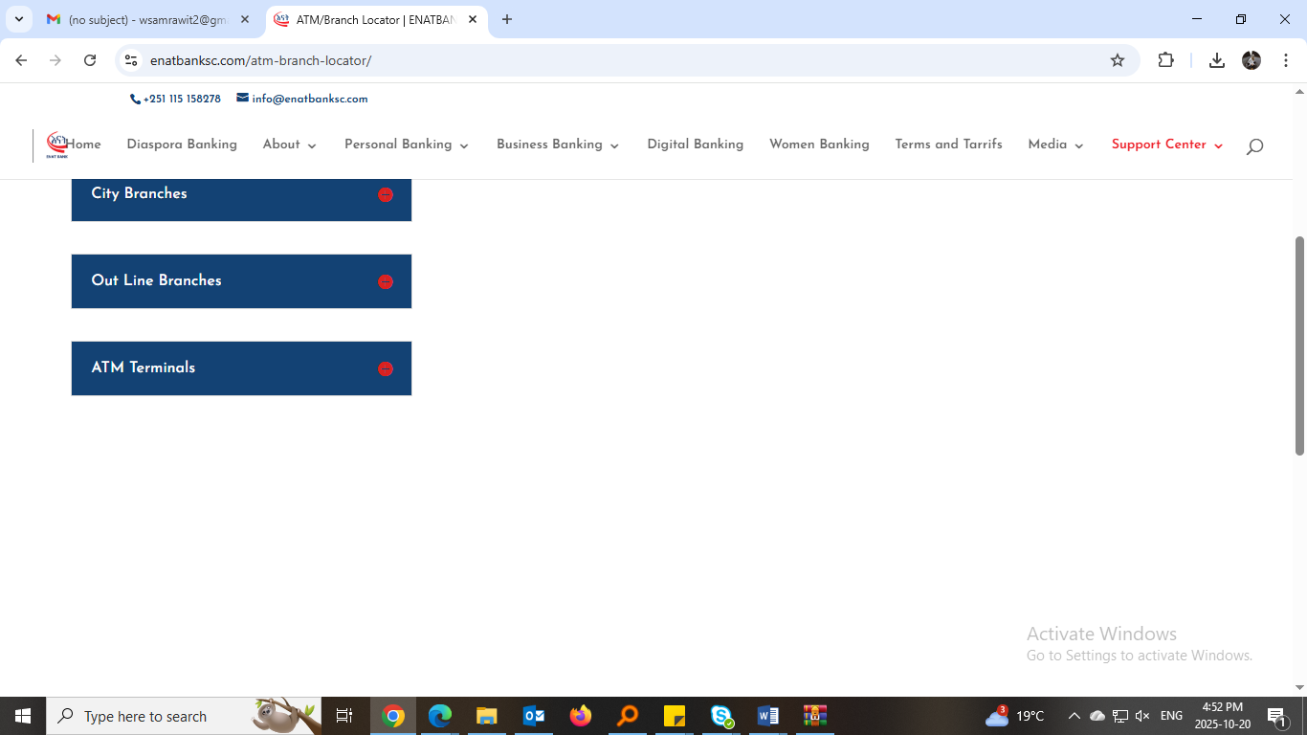
Appendix 1

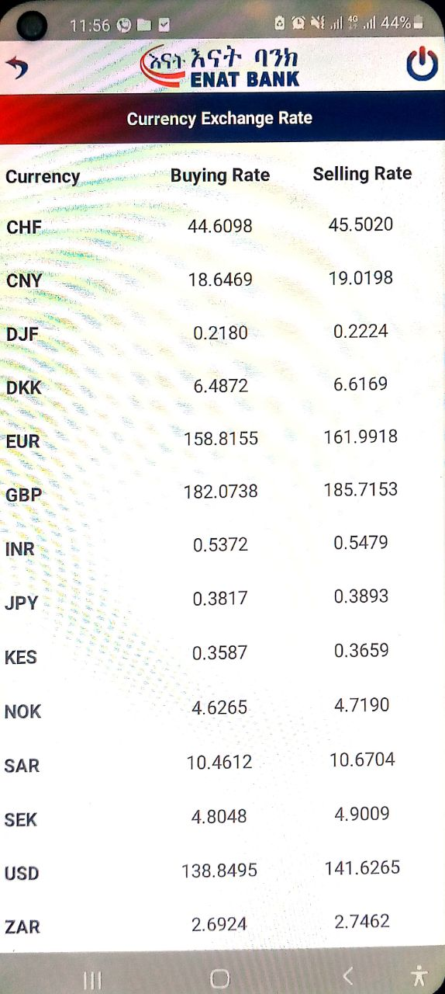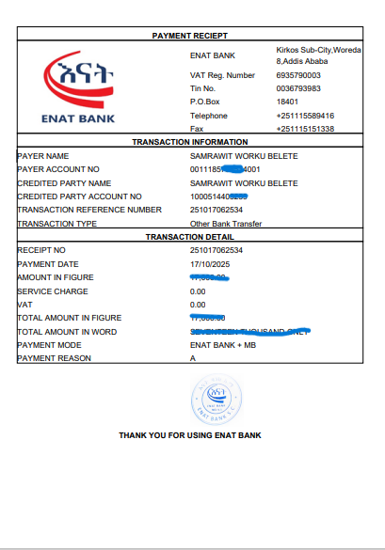
Appendix 2 Appendix 3

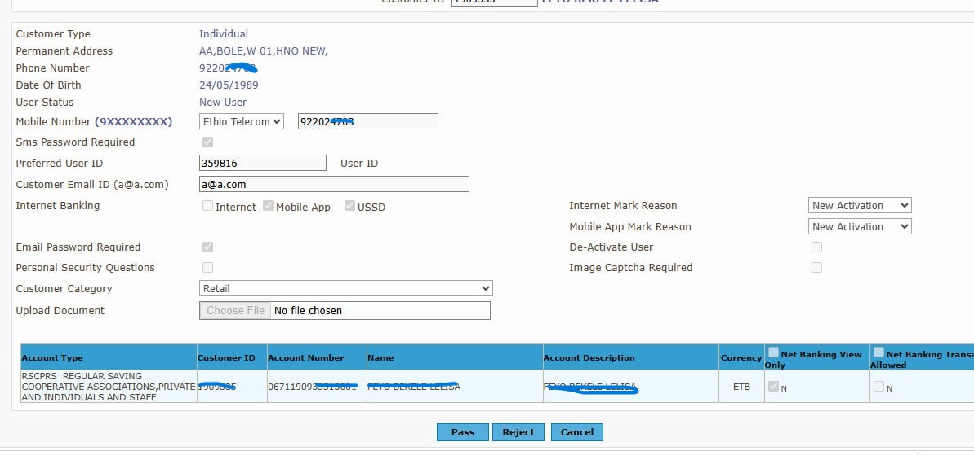
Appendix 4
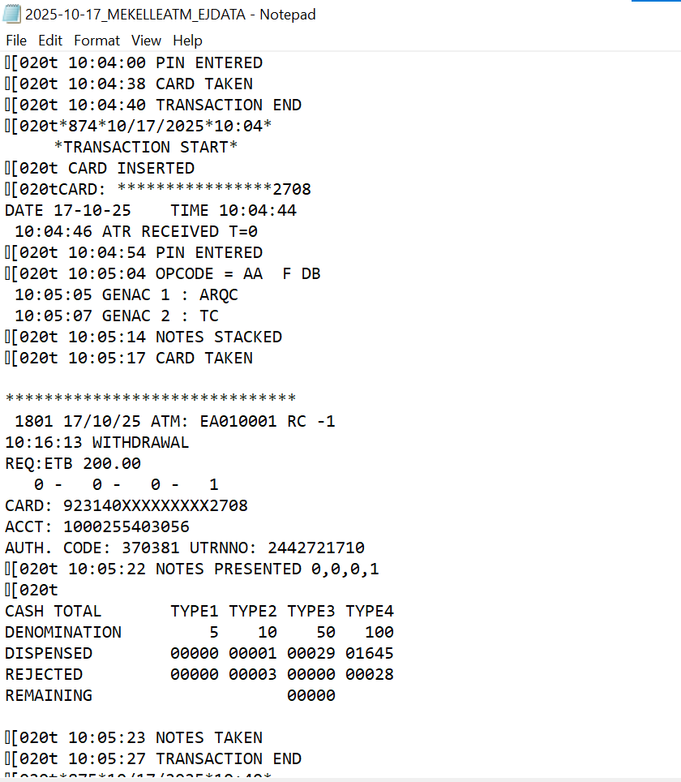
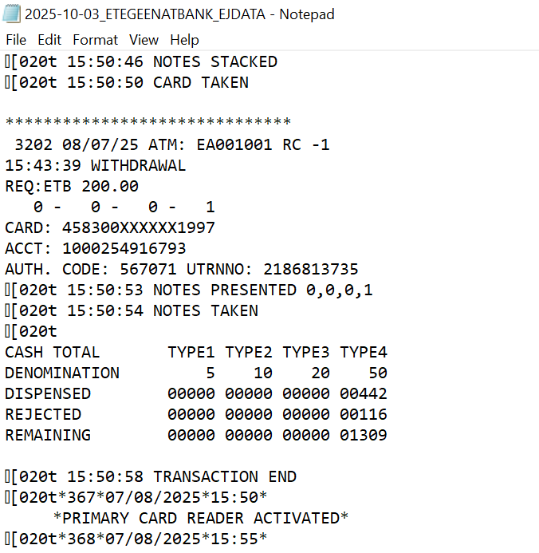

Appendix 5
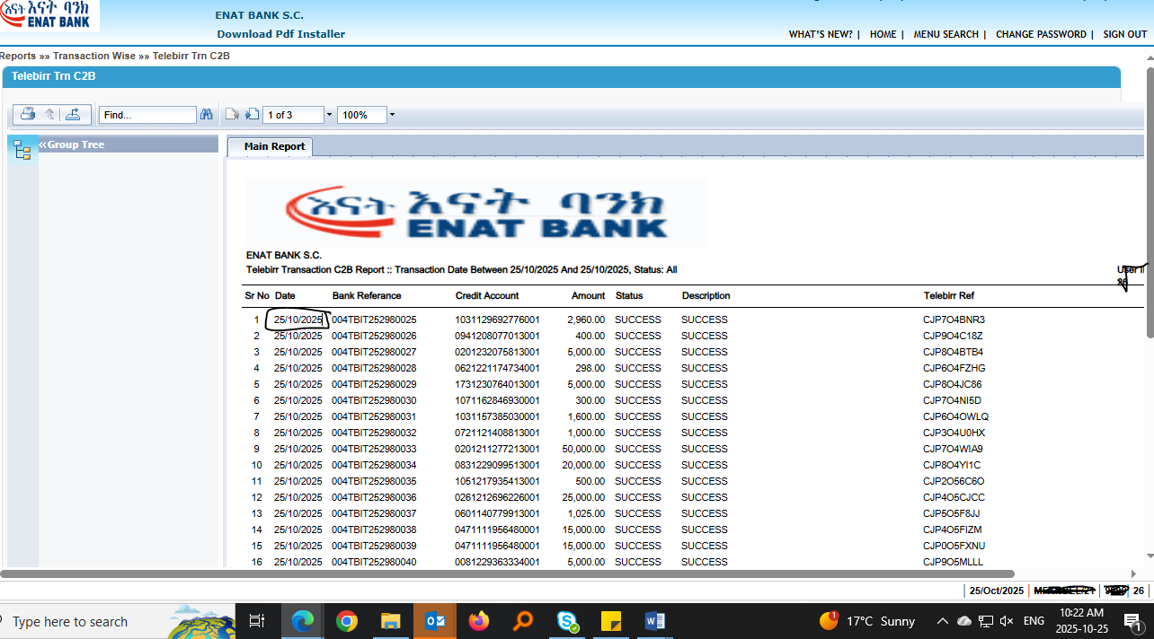
Appendix 6
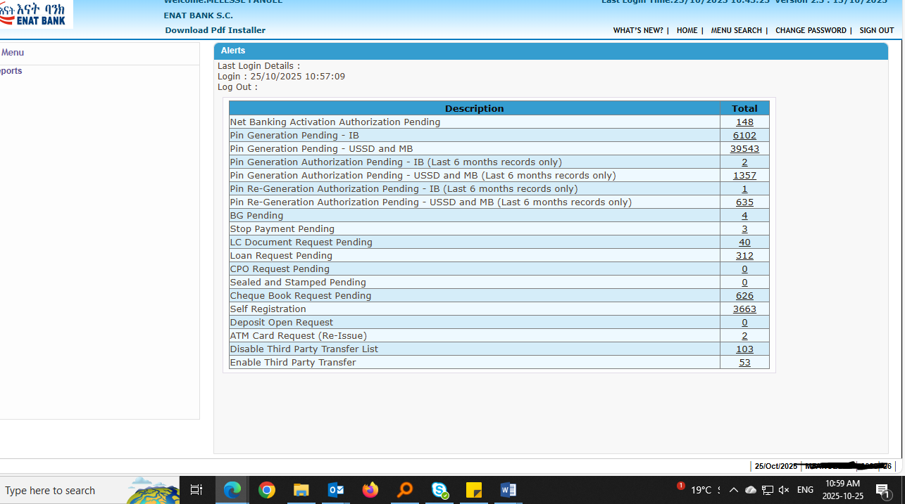
Appendix 7

